**Given a list of numbers - List[Int] (1, 2, 3, 4, 5, 6, 7, 8, 9, 10)**

**- find the sum of all numbers**

Val a= sc.parallelize(List(1,2,3,4,5,6,7,8,9,10))

a.reduce(_ + _)

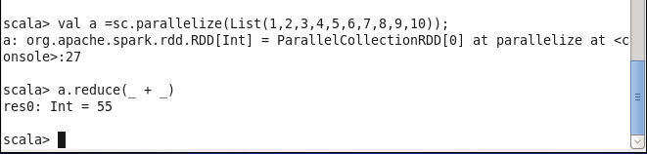

**- find the total elements in the list**

a.count()

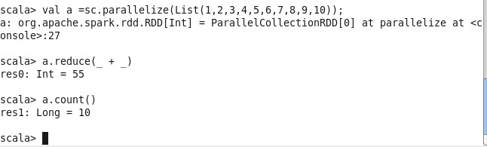

**- calculate the average of the numbers in the list**

Val a =sc.parallelize(List(1,2,3,4,5,6,7,8,9,10)

Val sum1 =a.reduce(_ + _)

Val avegerage =sum1/a.count

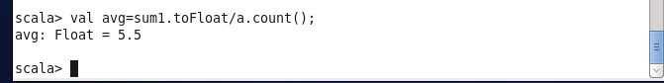

**- find the sum of all the even numbers in the list**

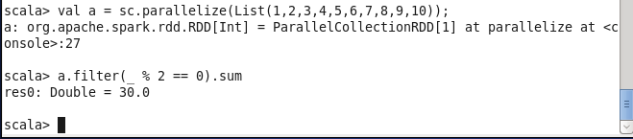

**- find the total number of elements in the list divisible by both 5 and 3**

